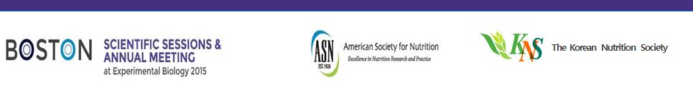

EB2015 International Forum–Korea
“Vitamin D: Why do we care?”

It is a great honor and pleasure announcing the EB 2015 International Forum-Korea.
This event will be held on March 29, 2015 from 3:00 – 5:00 PM at the Boston Convention & Exhibition Center in Boston, Massachusetts.

Under the main theme of “Vitamin D: Why do we care?” participants will discuss up-to-date scientific knowledge and Korean policy on vitamin D.
This program will provide a great networking opportunity with internationally prominent scholars, specialists and researchers attendance for this event.

We are looking forward to seeing you in Boston in this Spring!

[Program Overview]

Title | International Forum – Korea
Theme | “Vitamin D: Why do we care?”
Date & Time | Sunday, March 29, 2015 (3:00 PM-5:00 PM)
Venue | Education Track Room 151AB, Boston Convention & Exhibition Center
Organization | The Korean Nutrition Society (KNS)
Site | http://scientificsessions.nutrition.org/program/international-forum/
Program | Time Title Name  3:00 -3:10 Opening address Youn-Ok Cho, PhD (President of KNS)  Chairs: Kyung-Jin Yeum, PhD and Nam-Seok Joo, MD, PhD  3:10 -3:30 Vitamin D – Skeletal and non-skeletal actions. Nam-Seok Joo, MD, PhD, Ajou University School of Medicine, Suwon, Korea  3:30 -3:50 Update on vitamin D and the role in skeletal muscle. Lisa Ceglia, MD, Jean Mayer USDA-HNRCA, Tufts Univ Boston, MA  3:50 -4:00 Break  4:00 -4:20 Nutrition policy in Korea: Focusing on micronutients. Youn-Ok Cho, PhD, Duksung Women’s University, Seoul, Korea  4:20 -4:40 Impact of vitamin D and calcium insufficiencies on bone health in Korea. Kyung-Jin Yeum, PhD, Konkuk University, Chungju-si, Korea  4:40 -5:00 The new Korean dietary reference intakes (KDRIs) for vitamin D. Jung-Hyun Kim, PhD, Pai Chai University, Daejeon, Korea
Registration | - Deadline: March 10, 2015  - no fee  - forum proceeding, individual name tag will be provided  - e-mail (kns2@kns1.or.kr) attendee’s name, institute, e-mail address, phone number

